
s
DataBase System


LAB TASK-03

DataBase

Name: Samama Iqbal
Roll No: 2024-cet-16
Department: Software Engineering
Course Name: Database Systems
Instructor: Engr. Asma javed

Installation and Setup of Microsoft SQL Server 3
Task 01: Installation and Configuration 3
Objective: 3
Step-by-Step Installation of SQL Server 3
Task 02: Conceptual Questions 11
Q.1 What is SQL Server? Explain the purpose of the Database Engine and SQL Server Agent. 11
Q.2. Mention any two post-installation steps that must be done to verify successful installation. Identify two common installation errors and how to fix them 12
Q.3. How many types of instances are available in SQL Server? Differentiate between them. 13
Q.4. How many authentication modes are available in SQL Server? Which one is best to use and why? 14
Q.5. what are SQL Server Analysis Services (SSAS)? 14
Conclusion: 16

Lab Task – 03: Installation and Setup of Microsoft SQL Server

Task 01: Installation and Configuration

Objective:

The purpose of this task is to help students successfully install Microsoft SQL Server and SQL Server Management Studio (SSMS) on their system, properly configure it by creating a Named Instance using their full name, and then verify the setup by connecting to the instance through SSMS.

Step-by-Step Installation of SQL Server
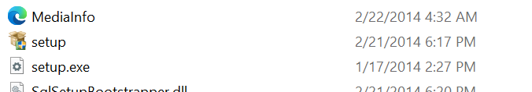

- Step 1: Run the Installer, from here select custom option.
- Step 2: Additional setup files starting download.
Click “install”
- Step3:
- After completion, the SQL Server Installation Center will open automatically.
- Click on “New SQL Server stand-alone installation or add features to an existing installation.”
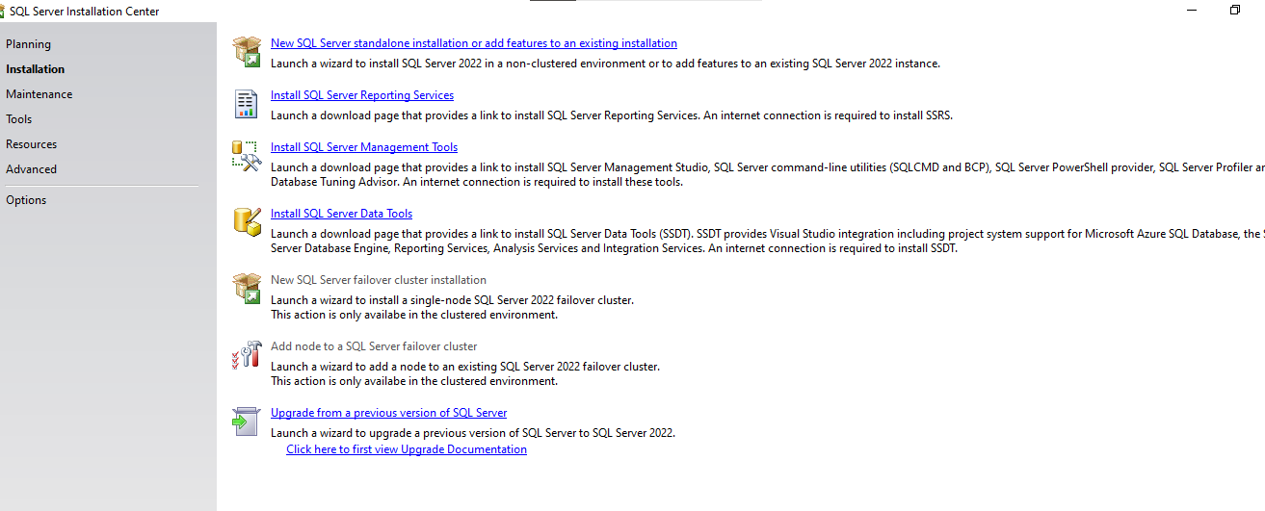
- Step7: In Microsoft update, click next.

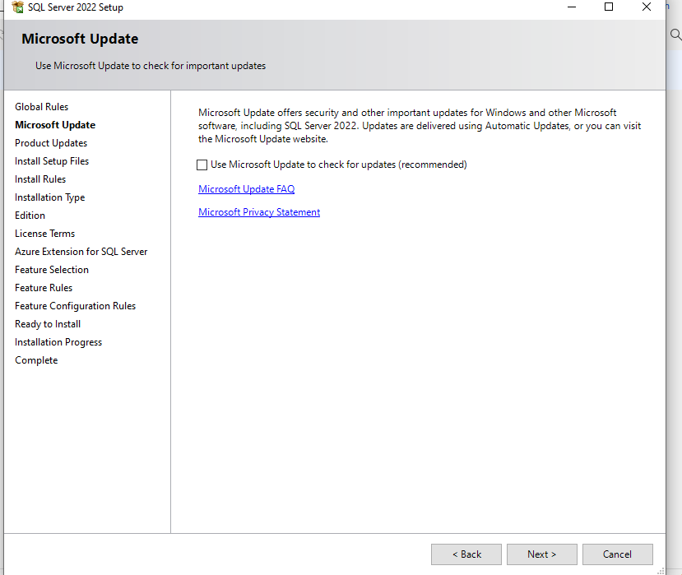

- Step 8: The installer will check system requirements and then click next.
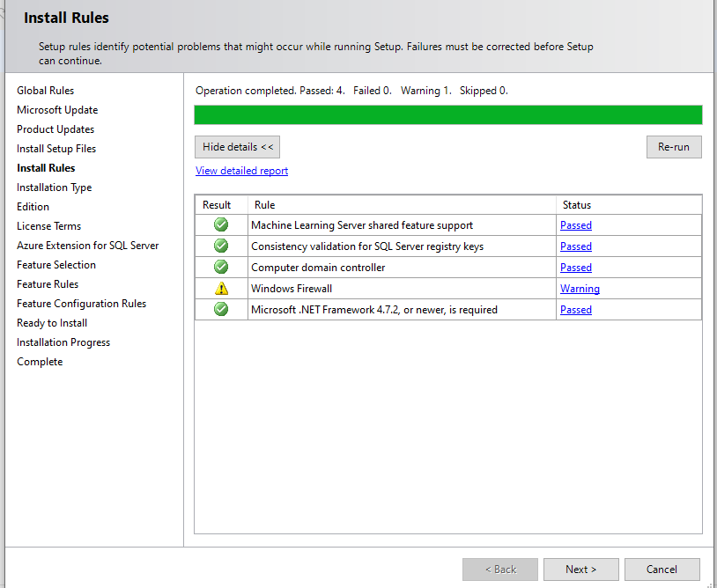
Step 9: Then install Setup rules



- Step 10: In both installation type and edition Perform a new installation and click next.

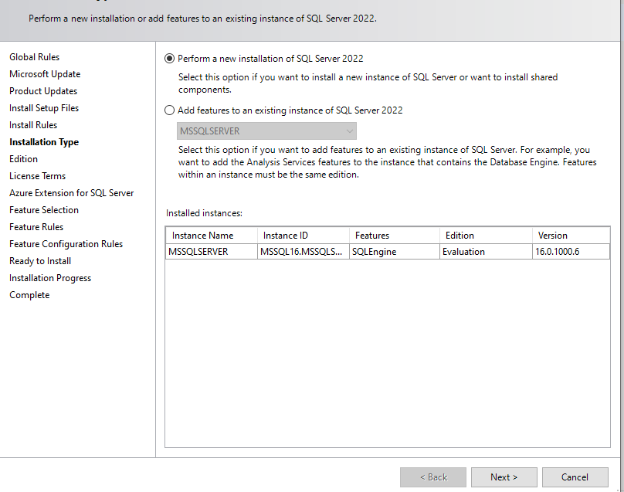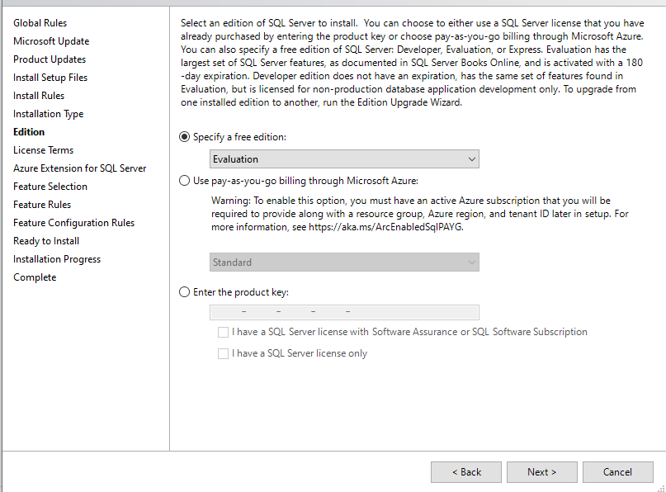

- Step 11:In Accept License Agreement Tick the box to accept the license terms and Click Next to proceed
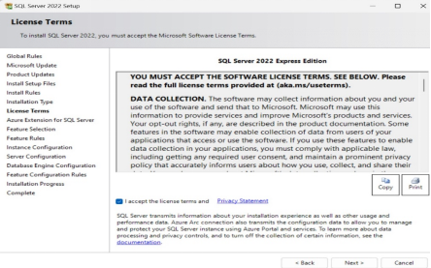

Step12: Configure Instance Name
Enter my full name in UPPERCASE with underscore i.e HAMMAD_AHMED and Click Next to proceed.

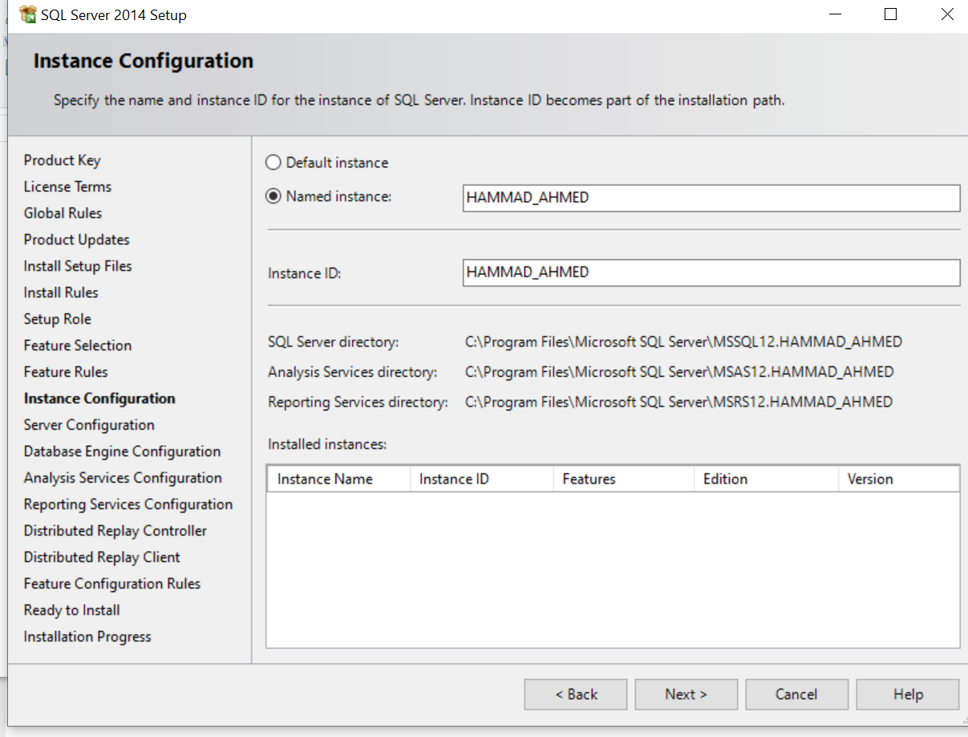

- Step 13: In Server Configuration, Just click next without changing anything.

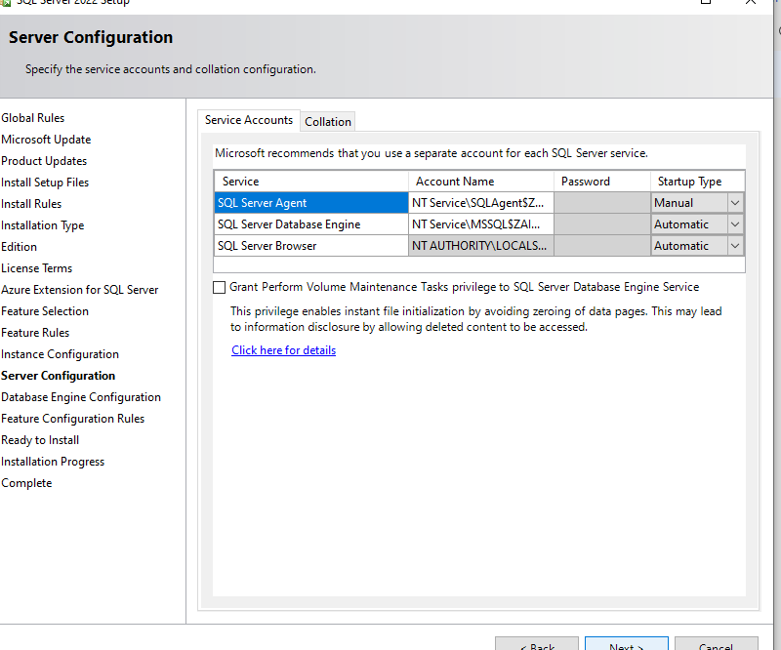
Step 14: In Database Engine Configuration, add customer user and then click next.
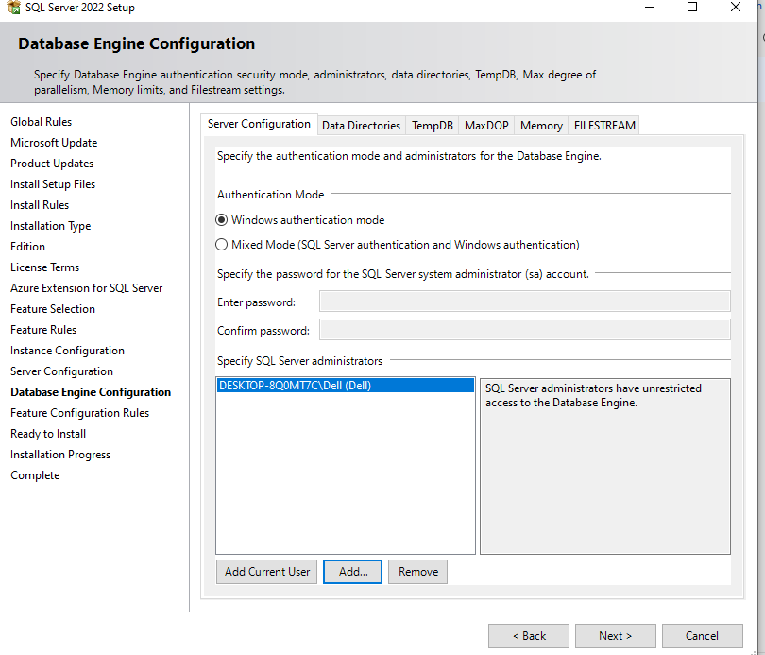

Step15: click install to start installation and then click close.

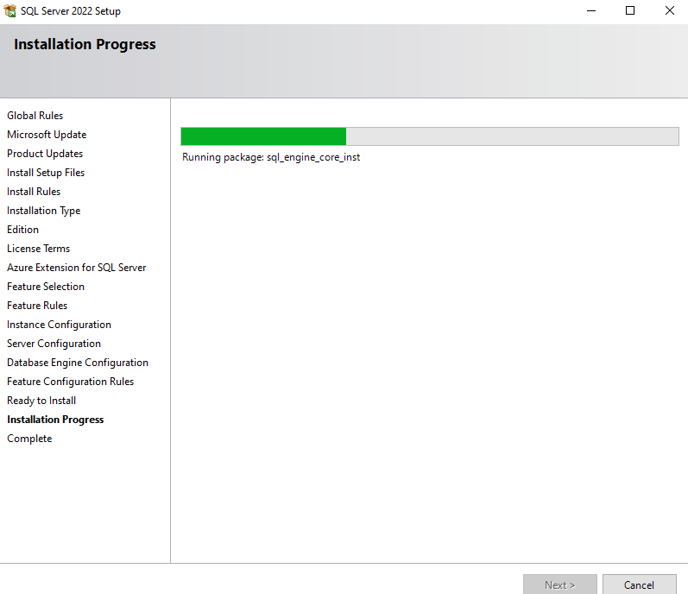

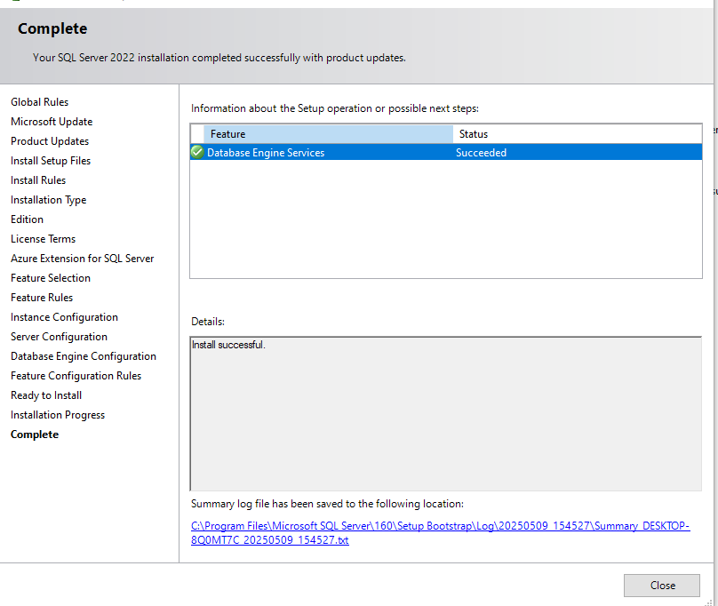

Step 16: After closing the installer ,then download and install SSMS(SQL Server Management Studio) , Restart your PC if needed.


Step 17: Connect to SQL Server Using SSMS, Launch SQL Server Management Studio from the Start Menu.
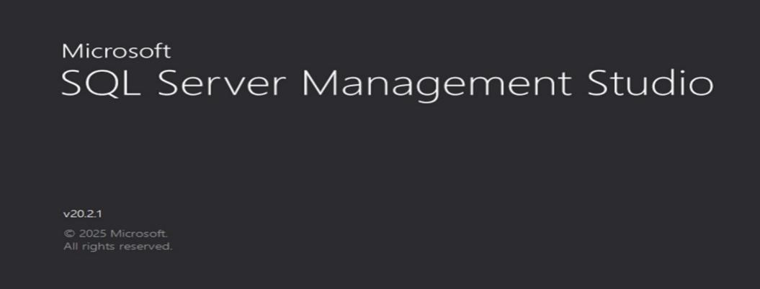

- Step 18:Enter Server Details
- Server Type: Database Engine
- Server Name:HAMMAD_AHMED
- Authentication: Choose either Windows Authentication
- Click Connect.

Task 02: Conceptual Questions

Q.1 What is SQL Server? Explain the purpose of the Database Engine and SQL Server Agent.
What is SQL Server?
Microsoft SQL Server is a powerful relational database management system (RDBMS) developed by Microsoft. It is designed to store, retrieve, and manage data for applications ranging from small desktop tools to large-scale enterprise systems. SQL Server uses Structured Query Language (SQL) as its standard interface for accessing and manipulating data.
SQL Server provides high performance, scalability, and reliability, and it is widely used in industries like banking, healthcare, e-commerce, and government. It supports features like data warehousing, data integration, business intelligence, and advanced analytics.

Purpose of the Database Engine:
The Database Engine is the core service for storing, processing, and securing data in SQL Server. It handles all tasks related to data management.
Key Functions:
- Storage and Retrieval of Data: Manages the creation and storage of databases, tables, indexes, views, and stored procedures.
- Transaction Management: Ensures data consistency using ACID properties (Atomicity, Consistency, Isolation, and Durability).
- Query Processing: Optimizes and executes SQL queries efficiently using a cost-based optimizer.
- Security Management: Controls access through user roles, permissions, and encryption.
- Concurrency Control: Handles multiple users accessing the database at the same time without conflicts using locks and isolation levels.
- Backup and Restore: Enables database backups and restores to ensure data safety and recovery.
In short, the Database Engine is responsible for all fundamental data operations and is the backbone of SQL Server.
Purpose of SQL Server Agent:
SQL Server Agent is a Windows service that allows database administrators to automate tasks within SQL Server. It helps reduce manual effort by running predefined jobs, alerts, and schedules.
Key Features:
- Job Scheduling: Automates routine tasks like backups, index rebuilding, and report generation. Jobs can be scheduled to run once or on a recurring basis.
- Alerts and Notifications: Sends alerts to administrators if specific conditions are met (e.g., low disk space, failed job).
- Monitoring: Keeps a log of executed jobs, including start time, end time, status, and messages, making it easier to troubleshoot.
- SQL Server Integration: Works closely with the SQL Server Database Engine to execute T-SQL scripts, SSIS packages, and command-line tools.
SQL Server Agent is essential for automating database maintenance, improving efficiency, and ensuring critical tasks are not missed.
Component | Description | Role
SQL Server | RDBMS platform developed by Microsoft | Stores and manages data using SQL
Database Engine | Core component of SQL Server | Handles data storage, processing, querying, and security
SQL Server Agent | Background job scheduler | Automates administrative tasks and job monitoring

Q.2. Mention any two post-installation steps that must be done to verify successful installation. Identify two common installation errors and how to fix them

Post-Installation Steps and Common Installation Errors in SQL Server
Two Post-Installation Steps to Verify Successful Installation:
- Check SQL Server Services via SQL Server Configuration Manager:
  - Open SQL Server Configuration Manager.
  - Ensure that the essential services such as:
    - SQL Server (MSSQLSERVER or Instance Name)
    - SQL Server Agent
    - SQL Server Browser (if needed)
  - Are all listed as "Running".
  - This confirms that the core components of SQL Server are active and functional.
- Connect to the SQL Server Using SQL Server Management Studio (SSMS):
  - Launch SSMS.
  - In the Connect to Server window, enter the server name or instance (e.g., localhost or .\SQLEXPRESS).
  - Use either Windows Authentication or SQL Server Authentication depending on your configuration.
  - Successful connection to the server confirms that SQL Server is installed properly and accessible.
Two Common Installation Errors and How to Fix Them:
- Error: SQL Server Service Fails to Start
  - Cause: Incorrect service account permissions, missing files, or port conflicts.
  - Fix:
    - Open SQL Server Configuration Manager and check the log on account used for the SQL Server service.
    - Ensure the account has appropriate administrative privileges.
    - Confirm that TCP/IP and Named Pipes are enabled in network configuration.
    - Restart the service or reconfigure the account settings.
- Error: "Rule 'ComputerDomainControllerCheck' failed."
  - Cause: SQL Server setup may fail on a domain controller due to restricted security settings.
  - Fix:
    - It's generally not recommended to install SQL Server on a domain controller.
    - If needed, run setup using Command Prompt as Administrator with the flag /SKIPRULE=ComputerDomainControllerCheck to bypass the check (not ideal for production).

Q.3. How many types of instances are available in SQL Server? Differentiate between them.
SQL Server provides two types of instances:
- Default Instance:
  - Automatically created during installation.
  - Accessible using just the hostname (e.g., localhost).
  - Only one default instance can exist per server.
- Named Instance:
  - Custom-named instances installed in addition to or instead of the default.
  - Accessed using hostname\instance name.
  - Multiple named instances can exist on the same machine.
Difference: Default instance has a standard name and simpler connection, while named instances allow multiple isolated installations on the same server.
Feature | Default Instance | Named Instance
Instance Name | Always MSSQLSERVER | Custom, user-defined name
How to Connect | Use just the server name | Use server name\instance name
Number of Instances | Only one instance can be installed | Can have multiple instances
Best For | Simpler setups or single environments | Complex setups or environments needing isolation

Q.4. How many authentication modes are available in SQL Server? Which one is best to use and why?

Authentication Modes in SQL Server:
SQL Server provides two authentication modes:
- Windows Authentication Mode:
  - Uses the Windows operating system credentials to authenticate users.
  - Users do not need to enter a separate username or password when connecting.
  - It supports advanced security features like Kerberos protocol, Active Directory integration, and single sign-on (SSO).
  - Access is managed using Windows user accounts and groups.
- SQL Server Authentication Mode (Mixed Mode):
  - Allows authentication using SQL Server-specific usernames and passwords.
  - Commonly used for external applications or when Windows Authentication is not practical.
  - Admin must manage SQL logins, passwords, and permissions separately within SQL Server.
Which Mode is Best and Why?
Windows Authentication Mode is generally considered the best and most secure option for the following reasons:
- Integrated Security: No need to store or transmit credentials separately.
- Stronger Security Management: Benefits from Windows password policies, account lockout, and auditing.
- Centralized Control: Access is managed via Active Directory, simplifying user management and permission settings.
- Reduced Risk: Eliminates hardcoded or shared SQL credentials, minimizing the chance of unauthorized access.
Summary:
Mode | Security | Management | Recommended For
Windows Authentication | High | Centralized via Windows | Enterprise environments
SQL Server Authentication | Moderate | Managed within SQL Server | Legacy apps, external access

Q.5. what are SQL Server Analysis Services (SSAS)?
SQL Server Analysis Services (SSAS) is a component of Microsoft SQL Server used for analytical data processing, especially for online analytical processing (OLAP) and data mining. It enables businesses to analyze large volumes of data and gain insights through fast, multidimensional queries.
SSAS is commonly used in Business Intelligence (BI) systems to create data models that help decision-makers visualize, explore, and summarize data efficiently.
How SSAS Works:
- Data Source: SSAS connects to a relational database (like SQL Server) or other data sources.
- Data Modeling: Developers create cubes or tabular models with relationships, hierarchies, and calculated fields.
- Processing: Data is loaded and aggregated within SSAS.
- Client Tools: Tools like Excel, Power BI, or SSRS connect to SSAS to visualize and analyze data.
Key Features of SSAS:

1. Multidimensional and Tabular Models:
- Multidimensional Mode (OLAP):
  - Data is organized into cubes.
  - Supports complex aggregations, slicing, and dicing of data.
  - Best for traditional BI systems with structured hierarchies.
- Tabular Mode:
  - Uses in-memory storage (VertiPaq engine) for faster performance.
  - Easier to design using familiar concepts like tables and relationships.
  - Supports the DAX (Data Analysis Expressions) language for calculations.
2. Cubes and Dimensions:
- Cubes: Represent multidimensional data (e.g., sales by time, region, and product).
- Dimensions: Define perspectives such as time, geography, product category.
- These structures enable fast and intuitive querying.
3. Measures and KPIs:
- Measures: Aggregated numerical data such as total sales, profit, etc.
- KPIs (Key Performance Indicators): Visual indicators to monitor performance goals.
4. Data Mining:
- SSAS provides algorithms to uncover patterns, trends, and predictions from data (e.g., customer buying patterns, sales forecasts).
Typical Use Cases:
- Business dashboards and scorecards
- Sales trend analysis
- Budget forecasting
- Customer behavior analysis
- Executive reporting
Feature | Description
SSAS | A SQL Server component for building analytical models
Modes | Multidimensional (OLAP) and Tabular
Main Use | Business Intelligence, trend analysis, data mining
Tools | Power BI, Excel, SSRS

Conclusion:
In this lab, I successfully installed Microsoft SQL Server and SSMS, configured a named instance, and connected to it using SSMS. I also learned key concepts such as the roles of the Database Engine and SQL Server Agent, authentication modes, instance types, post-installation checks, and the purpose of SQL Server Analysis Services (SSAS). This task improved both my practical setup skills and theoretical understanding of SQL Server.

__The End__

